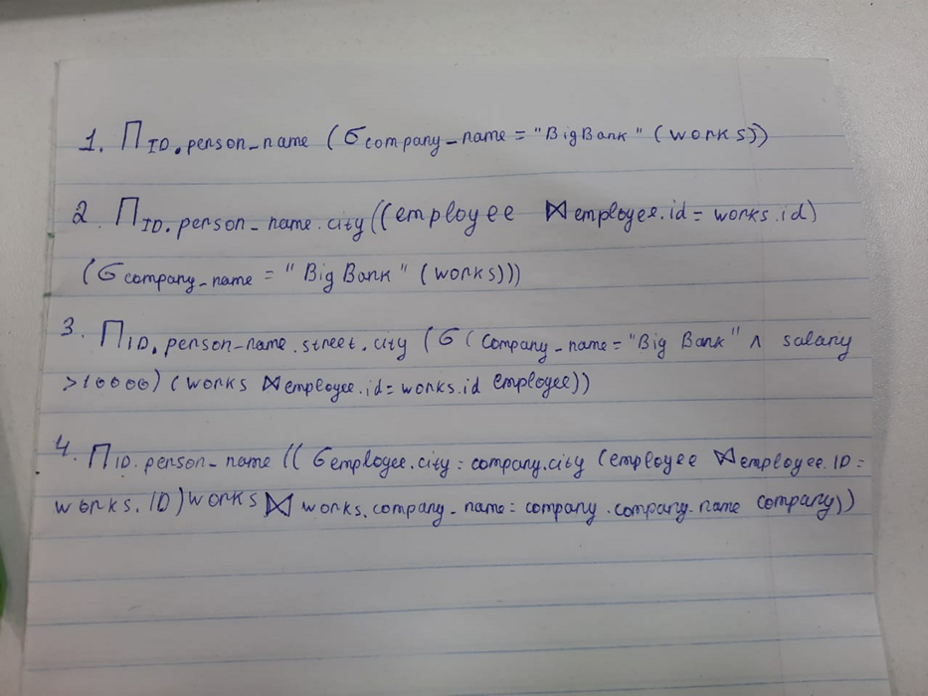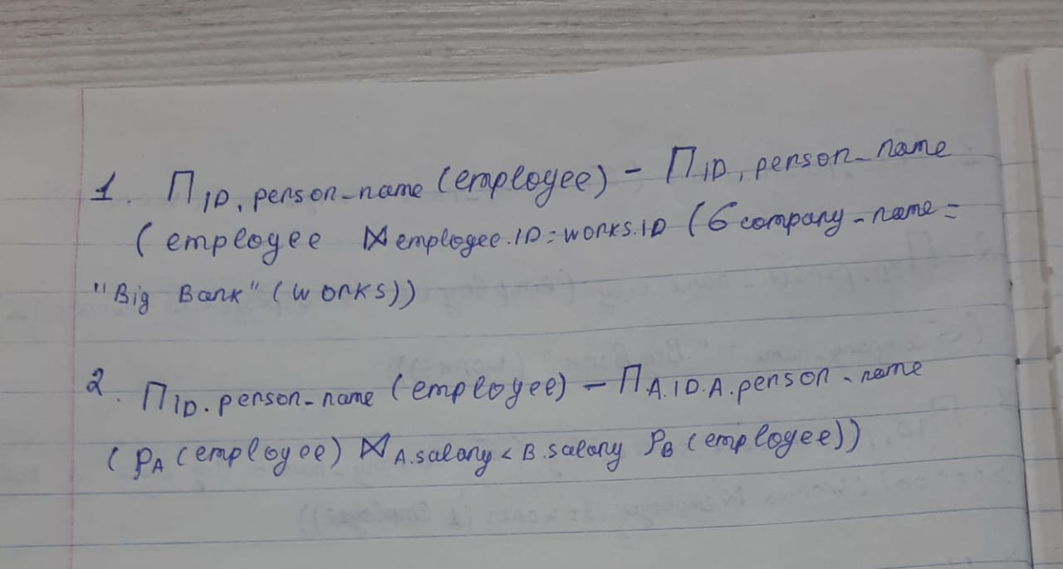



3.

**Insertion:**

As Instructor is child table of department for attribute **dept_name**, then adding something in instructor table which is not in department table will cause error. For example if we add economics as dept_name in instructor table but department table don’t contain it then it is a violation of foreign key constraint.

**Deletion:**

As department is parent table of instructor for attribute **dept_name**, then deleting something in department table which is present in instructor table will cause error. For example if we delete economics as dept_name in department table but instructor table do contain it then it is a violation of foreign key constraint

4.

Primary key is an attribute in a table which can uniquely identify that table. In employee table the **person_name**, in works table **person_name**and in company table **company_name**are the primary keys.